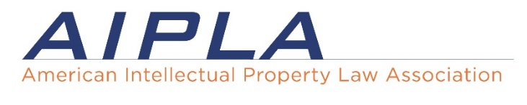
Patent Prosecution Boot Camp | February 7-9, 2024
Silicon Valley Regional Office of the US Patent & Trademark Office
26 S. Fourth Street, San Jose, CA 95112

Wednesday, February 7, 2024

8:00 am - 5:30 pm Registration and CLE Information
8:00 - 8:30 am Breakfast, Registration, and Networking

Application Preparation
Lead by: Stefan Osterbur, Van Hoven P.C.
8:30 - 8:40 am Opening Remarks
USPTO Regional Director Mary Fuller
8:40 - 9:15 am Initial Inventor Interview and Invention Disclosure
Stephanie Kwong, Abbott Labs
9:15 - 9:45 am Inventorship
Elliot Karlin, Samsung Semiconductor
9:45 - 10:15 Patent Search and Opinions
Rocky Lieberman, Lieberman & Brandsdorfer, LLC
10:15 - 10:30 am Break
10:30 - 11:00 am Filing Formalities
Justin Cassell, Workman Nydegger
11:00 - 12:15 pm Overview of Design Patents
Margaret Polson, Polson IP Law
12:15 - 1:00 pm Lunch
1:00 - 1:45 pm Application Drafting and Provisional Applications
Jordan Becker, Perkins Coie LLP
1:45 - 5:30 pm Claims Drafting Workshops (Break: 3:45 - 4:00 pm)
Mechanical
David A. Randall, Orbit IP
Josh Van Hoven, Van Hoven P.C.
Wade Miles, USPTO
Electrical
Lucas Hjelle, Schwegman Lundberg & Woessner, PA
Marc Richards, Crowell & Moring LLP
Violeta Prieto, USPTO
Biotech/Pharma/Chemical
Nichole Valeyko, Merck
Michelle O’Brien, The Marbury Law Group, PLLC
Ali Soroush, USPTO

5:30 - 6:30 pm Welcome Reception
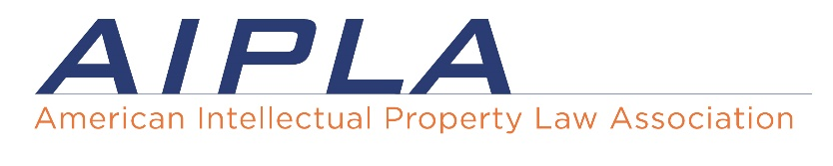
Thursday, February 8, 2024

8:00 am - 5:30 pm Registration and CLE Information
8:00 - 8:30 am Breakfast and Networking

Prosecution of Patent Applications
Lead by: Tony Curtis, Schwegman Lundberg & Woessner, PA

8:30 - 9:15 am Responding to § 101 and § 112 Rejections
Vicki Norton, Duane Morris
Jennifer Rogers, Shumaker & Sieffert
9:15 - 9:45 am Responding to § 103 Rejections
Mauricio Uribe, Knobbe Martens
9:45 - 10:30 am Restriction, Elections, and Double Patenting
Brian Whipps, Mueting Raasch Group
10:30 -10:45 am Break
10:45 -11:15 am Continuations and RCEs
Phil Harris, Holland and Hart
11:15 am - 12:15 pm Ethics, IDS & Duty of Candor
Tom Irving, The Marbury Law Group, PLLC
12:15 – 1:15 pm Lunch
1:15 - 1:45 pm Examiner Interviews & Knowing the USPTO
Yelena Morozova, Finnegan, Henderson, Farabow, Garrett & Dunner, LLP
1:45 - 2:00 pm Break
2:00 - 5:30 pm Responding to Office Actions Workshops (Break: 3:45 - 4:00 pm)
Mechanical
Rakhi Nikhanj, Mueting Raasch Group
Andy Johnson, Donaldson Company
Wade Miles, USPTO
Electrical/Software
David Trossen, Knobbe Martens
Brian Graham, Knobbe Martens
Violeta Prieto, USPTO
Biotech/Chemical
Ricardo Moran, Schwegman Lundberg & Woessner
Greg Zinkl, Genentech
Ali Soroush, USPTO

February 9, 2024

8:00 am - 1:00 pm Registration and CLE Information
8:00 - 8:30 am Breakfast and Networking

Digging Deeper: Petitions, Appeals, Post-Grant Proceedings, & Int’l Practice
Lead by: Stefan Osterbur, Van Hoven P.C.
Tony Curtis, Schwegman Lundberg & Woessner, PA

8:30 - 9:30 am Petitions and Appeals
Adam R. Stephenson, Adam R. Stephenson, LTD
9:30 - 10:15 am Prosecution Tips from Patent Litigator's Perspective
Paul D. Tripodi II, Akin Gump
Brandon Rash, Akin Gump
10:15 - 10:30 am Break
10:30 - 11:15 am Issuance, Patent Term, Certificate of Correction, Disclaimers & Maintenance
Robert Mazzola, Pied Parker
11:15 am - 1:00 pm PCT Filings and International Patent Prosecution
Mark St. Amour, Bejin Bieneman
1:00 pm Concluding Remarks

