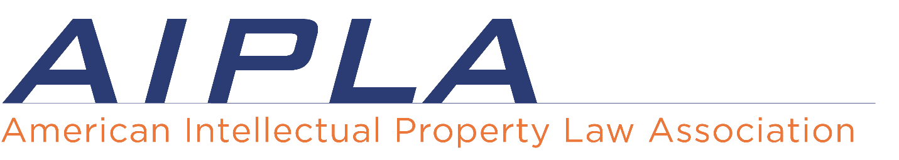

**AIPLA Committee Report and Workplan 2023**

DATE: [insert date] MEETING: [insert meeting title]

COMMITTEE NAME:

COMMITTEE LEADERSHIP: [list chair, vice-chair, co-chairs, etc,.]

SUBCOMMITTEES: [list subcommittees and leadership if any, and how they support the programs/activities of the committee]

DISCUSS THE OVERALL MISSION OF THE COMMITTEE AS IT RELATES TO AIPLA’s **Strategic Plan [**[**LINK TO CORE PURPOSE, MISSION, and VALUES**](https://www.aipla.org/about/about-us/aipla-strategic-plan)**] [**[**LINK TO STRATEGIC PLAN**](https://www.aipla.org/about/about-us/aipla-strategic-plan) **TARGET GROUPS - FAME]**:

**[Important Note:** You may not have items to report for each specific target group, and that’s OK. Please focus on those areas that you feel your committees activities will contribute to the overall goals of the Association.]

**PROJECTS:**

**PROJECTS:**

**Plans for stated meetings:** [Use this space to describe what your committee plans to do at each of the stated meetings including; 2024 Spring Meeting and Annual, this could include being a part of the planning committee and assisting in track development]

**Plans for coordination between stated meetings:** [Use this space to describe how the committee plans to interact and communicate between stated meeting. Also include any plans for non-stated meeting activities such as teleconferences, webinars, stand-alone meetings (road shows), etc.]

**Plans for communication with the committee clusters/board liaisons:** [ Use this space to report any action items or updates from regular information sharing sessions of the cluster, as it pertains to your committee’s work.]

AIPLA Strategies

• ***Foundational:*** Activities designed to support stewardship of member resources and their application to the Mission, Mission-based Goals, and the supporting organizational structure and staff of AIPLA.  
• ***Advocacy:*** Activities designed to improve the legal/regulatory climate within which IP is practiced, including but not limited to, awareness, understanding and acceptance of consistent IP laws and regulations within and across relevant jurisdictions.

• ***Membership/Community*** : Activities designed to improve membership acquisition and retention and to improve participants’ engagement with AIPLA.  
• ***Education:*** Activities designed to identify and build the IP, legal or practice, competencies of a target audience.

As mentioned above, your committee may not have activities that fit into every category. If there’s a strategy that doesn’t pertain to your plans, remove it from your report, or identify that there are no activities in that category that relate to your planned activities.